BE SMART

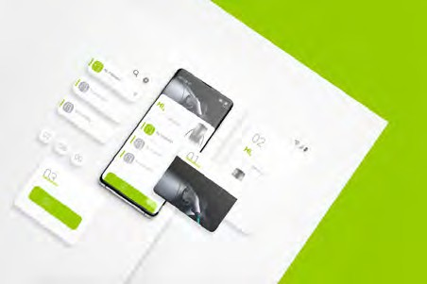

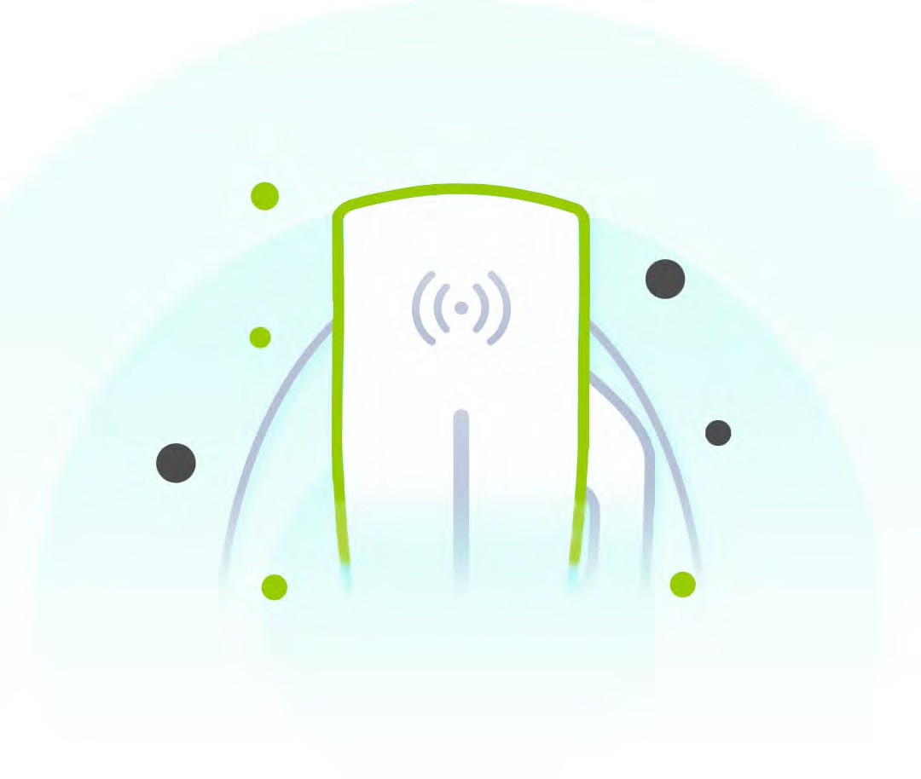

BADGER ENERGY

CONTENTS

App Introduction App Download

How to Connect the Device

How to Prevent Unauthorised Connections Viewing Data and Charging Status Settings Page

How to Switch Wi-Fi

Solutions for Failed Bluetooth or Wi-Fi How to Setup Timed Charging Sessions How to Set Operation and Current How to Perform a Software Update How to Download Updates

How to Use the DLB Function

How to Resolve Connectivity Issues

p1 p2 p3 p4 p5 p6 p7 p8 p9 p10 p11

p12 p13 p14

## BE Smart

App Introduction

The app allows you to remotely connect to a BPE EV charger via Bluetooth and Wi-Fi. The app can be easily connected to via a QR code or the serial number that can be found on the side of the charger. Once connected, real time data and charging information will be relayed to your mobile device.

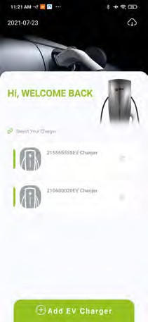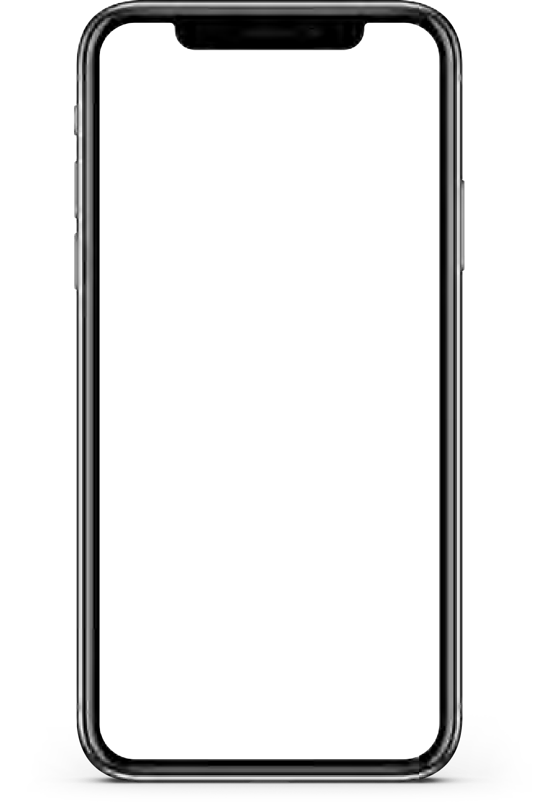

The main function of this app is to monitor charging information such as charging current, charging voltage, charging power & charging status. It is also possible to set timed charging, over heating protec- tion temperature, maximum charging current and different DLB modes depending on whether it is connected to a photovoltaic system or not.



App Download

Open Google Play





Search

“BE SMART”

Find “BE SMART” APP



Click “Download”

Open App Store



Search

"BE SMART"



Find “BE SMART” App

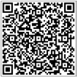

Click “Download”



BE SMART

# How to Connect the Charger

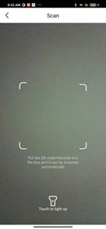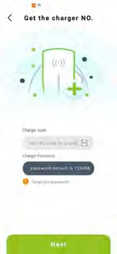

Operation:

1. Open the BE Smart App (ref image 1-1) and click the “Add EV Charger” icon.
2. Input the EV charger serial number manually or by scanning the QR code on the side of the EV charger to obtain the code.
3. Enter your password (default 123456), then click Next.
4. After successfully connecting, refer to the next section for instructions to set the name and password.

Note: The ﬁrst time you add an EV charger via

Bluetooth, please turn on the Bluetooth on



your mobile phone ﬁrst.

# How to Prevent Unauthorised Connections

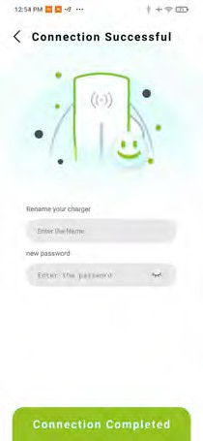

After adding the device successfully to the app, you can now enter a name and new password to complete the setup of the EV charger.

Caution:

1. The name and password can be used to distinguish the EV charger in the nearby area, and prevent others from connecting to this device.
2. If you do not update the name and password, it will remain as the default

name.



# Viewing Data and Charging Status

Once the charger is successfully connected to your device, you can check the real-time data and status of the EV Charger.

You can also set a timer if you are utilising an off-peak smart tariff. This information is available by selecting your charger in the window named “Select your Charger”.

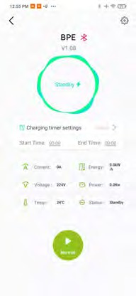

|  |  |
| --- | --- |
| Operating Current | Energy  Consumption |
| Operating Voltage | Charging Power |
| Charging  Temperature | Charging Status |



# Settings

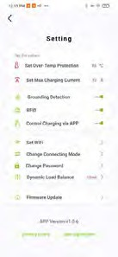

Page

Click the Settings button to enter the Settings screen.



In the settings screen you can check and set various charging conﬁgurations.

|  |  |
| --- | --- |
| Over Temp Protection | Max Output Current |
| Grounding Detection | RFID Card Activation |
| Control Charging via  App | Set Wi-Fi |
| Change Connection  Mode | Change Password |
| DLB Mode Selection | Firmware Update |



# How to Switch to Wi-Fi

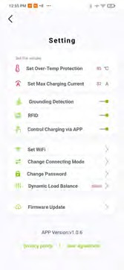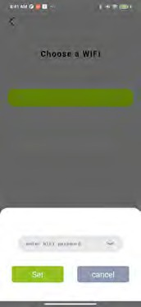

Function:

When the device and the charger are on the same Wi-Fi network, you can control the charger from a distance.

Operation:

1. In the settings screen (ref image 5-1), click the “Set Wi-Fi” button to enter the interface shown in image 5-2.
2. Select the appropriate Wi-Fi network (or manually type in the SSID) and enter the password, then click Connect.
3. After successful connection, click on Change Connecting Mode and switch from Bluetooth to Wi-Fi
4. Check the data display screen (ref

image 5-3) to see if Wi-Fi is switched on.





# Solutions for Failed Bluetooth or Wi-Fi Connections



### Press and hold the charger icon to disconnect from the device.

### Reconnect the device after deleting the charger.

1. Check if the EV charger is powered on. If not, please reconnect the power supply.
2. Please check that no other devices have been connected to the charger. If the charger is already connected, please disconnect the other devices ﬁrst.
3. When using the Wi-Fi communication, ensure that the Wi-Fi is turned on and the EV charger is on the same network. Only a 2.4GHz network can be used, 5GHz is not supported.



# How to Setup Timed Charging Sessions

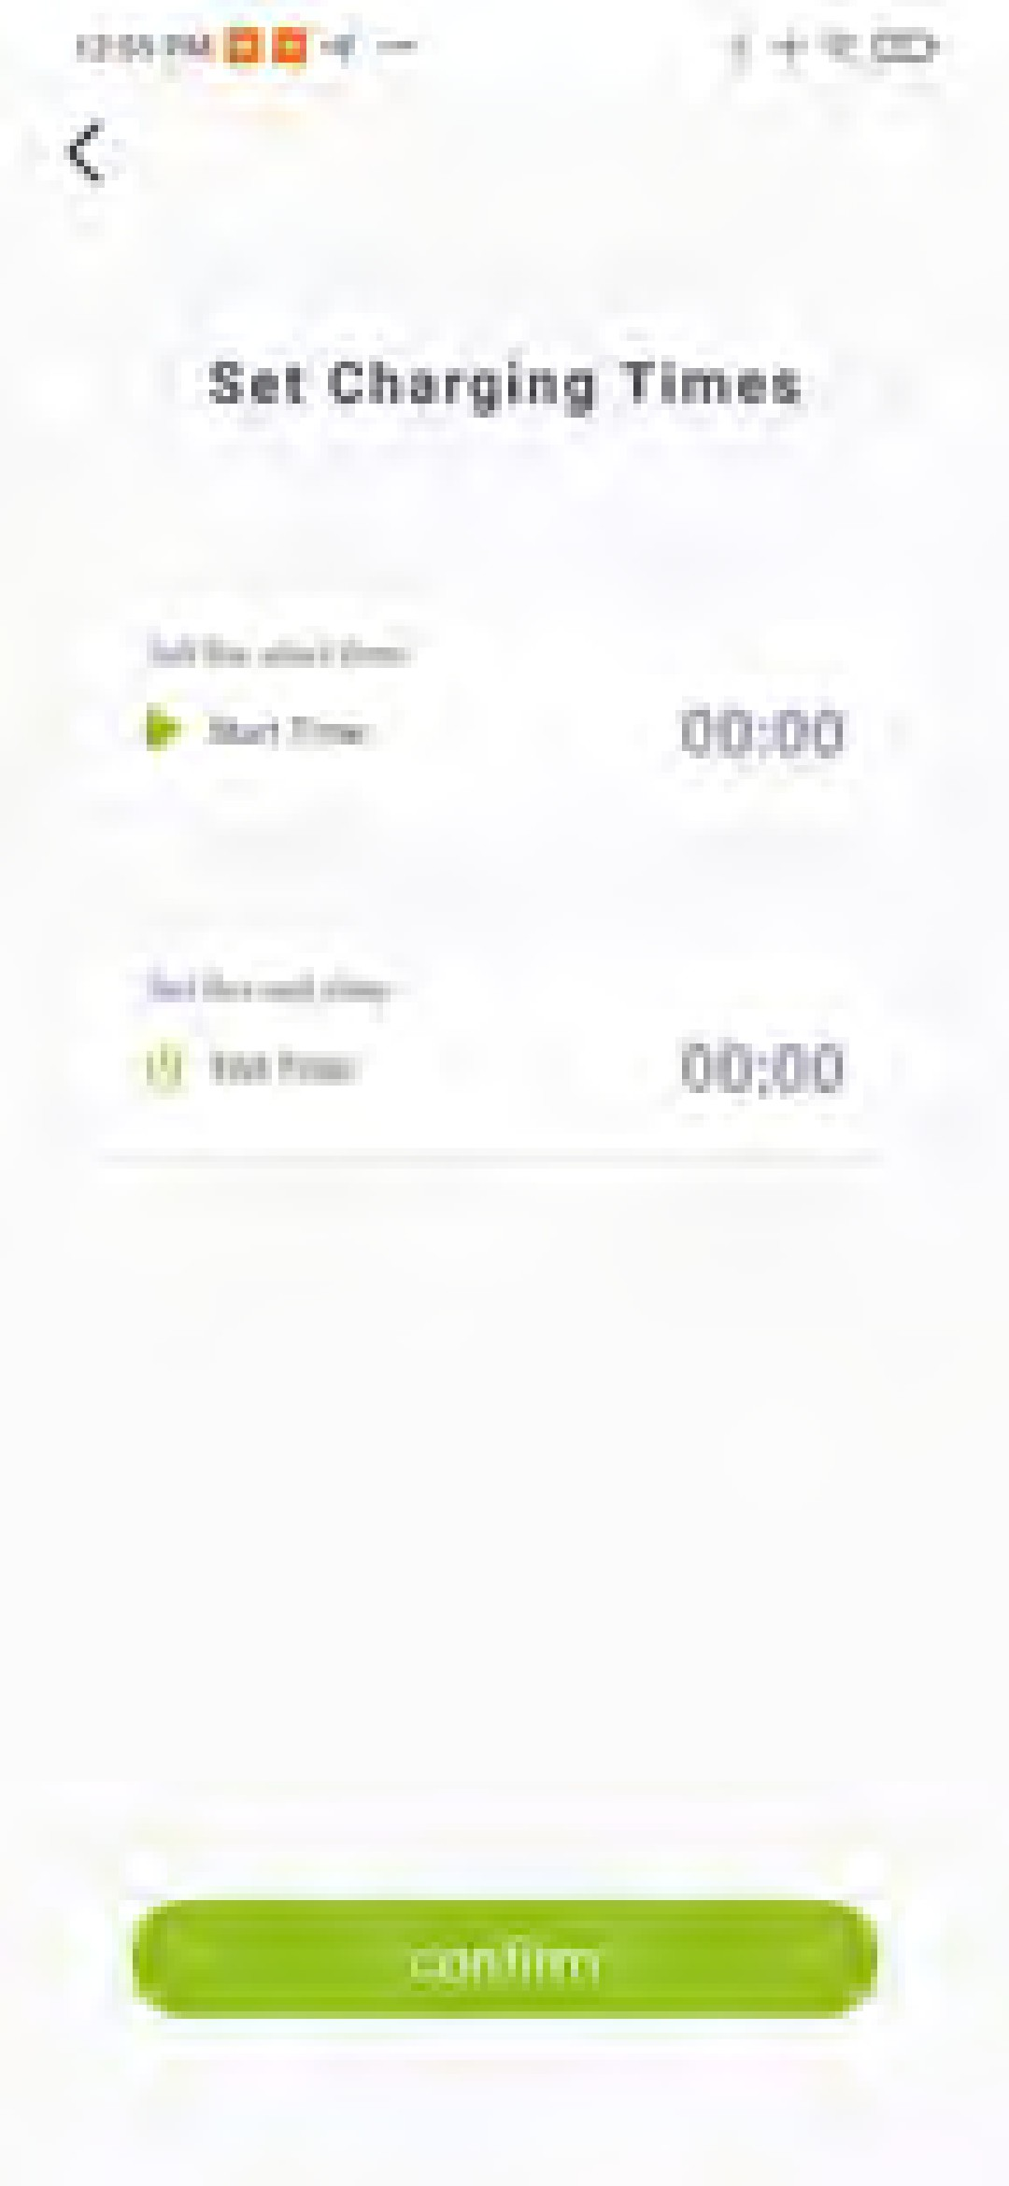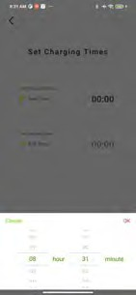

Function:

Proper implementation of charging periods with ﬂexible tariffs allows users to greatly reduce their charging costs.

Operation:

* 1. Once the charging socket is connected to the electric vehicle, then you will be able to set a timed charging session.
  2. Click on the EV charger icon shown in image 7-1 to enter the charging time setting interface.
  3. Set the ON/OFF charging times to match your flexible tariff to charge during those selected hours.



# How to Select Operation and Charging Current



Click on the “Set maximum charge current” button as shown in image 8-1. Set the appropriate charging current according to the desired charging power of the EV charger.



# How to Perform a Software Update



Function:

It’s imperative that the most up to date ﬁrmware is downloaded. This ensures that the user has the largest range of app features.

1. Click the “ﬁrmware upgrade” button as shown in image 9-1. Enter the software update screen.
2. If the latest version is detected you can click on the Update button in image 9-2 to complete the update.

Note: The software updates are not mandatory. Please make sure the Wi-Fi or data connection is consistent while updating.

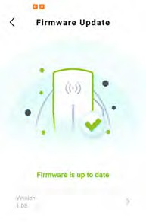

Function:

If the ﬁrmware upgrade process accidentally fails, it can be repaired by the ﬁrmware repair function.

* 1. Click the Repair button shown in image 10-1 to enter the ﬁrmware repair screen as shown in image 10-2.
  2. Click on the “QR code scan” button and then scan the QR code of the EV charger.
  3. Click on the “Repair” button and wait for it to complete.

Note: Please ensure that the bluetooth and network signal is good during this process. If the repair process is unsuccessful due to poor network conditions, please repeat the above steps.



# How to Download Updates

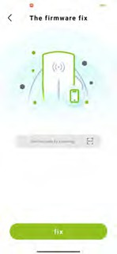

How to Use the DLB Function



The DLB is available in Normal, Solar PV, Mains Hybrid, and Full Speed mode which needs to be setup correctly to provide the user with the greatest benefit for their unique system.

1. Normal Mode: In the normal DLB mode, the EV charger will automatically adjust the charging current so that the total household electricity current is limited to the DLB setting value.



1. Photovoltaic mode: In this mode, the charger will use any excess generated Solar PV energy to charge the EV.
2. Hybrid mode: EV charger allows for max charging power with energy from the grid, but will combine it with any excess Solar PV energy to reduce the overall charging costs.

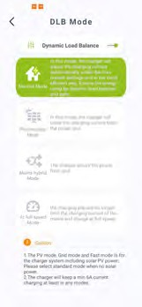

1. Full speed mode: EV charger will no longer limit the mains charging current and charging at full speed effectively.

The total household current can be limited by setting the rated current value of the DLB.

Note: All of these modes will charge at a base 6A from the grid once you plug the EV in or during your preset charging time window

(ref 11-1) Enter the Settings menu and then select the DLB function. Next, activate the DLB slider and select a mode as shown in image 11-2.



# How to Resolve Connectivity Issues

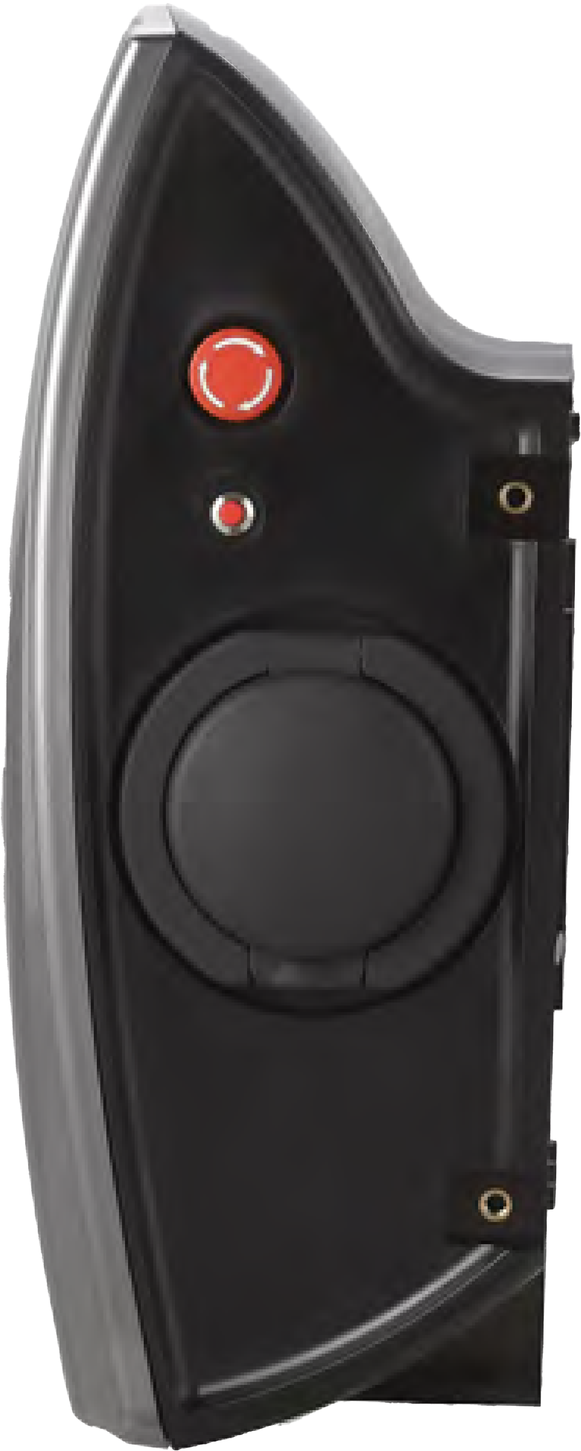

Leakage test butt

on



Operation:

Press and hold down the reset button on the side of the charger for 10 seconds; this will initialise bluetooth mode.

Note:

This function also allows the user to revert the charger to its factory settings.



